ENGR 200 FALL 2016

P6: ROCKET MOTOR THRUST AND IMPULSE
(using input/output data files, user-defined functions, loops, and if statements)

DUE: October 20, 2016 at 11:59 p.m. CT (extra credit)
October 25, 2016 at 11:59 p.m. CT (final deadline) POINTS: 60

INTRODUCTION:
Rocket motors are tested by restraining them on the ground, firing them with a known amount of propellant, and measuring the thrust over time. A typical curve is shown below.
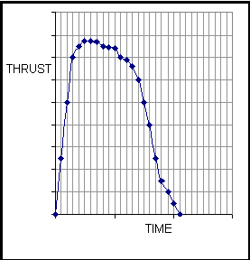
The total impulse is the integral of the thrust over the operating duration of the motor. This can be approximated by
I_{t} = Δt(F₁+F₂+F₃+…)
where: I_{t} = total impulse in lb-sec
Δt = time increment in seconds
F₁, F₂, F₃, … = thrust at timesteps 1, 2, 3, … in lb

The specific impulse is the total impulse divided by the weight of the propellant burned in the test.

I_{sp} = I_{t}/m
where: I_{sp} = specific impulse in seconds
m = mass of propellant burned in pounds

The average thrust is found by dividing the total impulse by the thrust time.

F_{avg} = I_{t}/t
where: F_{avg} = average thrust in lb
t = total test time in seconds

An input data file called time-thrust contains time, increment, and thrust data for a rocket test where the mass of propellant burned was 1.54 lb. The first record line of the input file is the control number which defines the number of data points to be read into the program. Each succeeding record line has three columns. The first column is the time in seconds, the second column is the increment between timesteps in seconds, and the third column is the thrust in pounds. The input file is comma delimited.

ASSIGNMENT:
Write a C program that will read the required values from the input file. Using the thrust, time, and increment between timesteps, compute the total thrust and write separate user-defined functions to compute the total impulse, specific impulse, and average thrust. Print the total impulse, specific impulse, and average thrust to the computer screen and to an output file called impulse-thrust.

OUTPUT FORMAT:
********************************************
ROCKET MOTOR TEST RESULTS

Total Impulse: XXX.X lb-sec
Specific Impulse: XXX.X sec
Average Thrust: XXX.X lb
********************************************

FILE PATHS:
Before submitting your C source program, make sure that you set your input and output file paths to
U:\ENGR 200\.

